Mrs. Bowen Rm. 112

Class Policies/Rules sbowen@Northmacschools.org
(All of which are subject to change/modification at any time)

Class Rules Consequences for failing to observe classroom rules

1. Do be polite 1. Verbal warning
2. Do talk at appropriate time 2. Conference with student to discuss behavior and solutions
3. Do come to class with materials 3. Detention
4. Do leave gum/candy in trash. 4. Referral to office
5. Do be seated before bell rings. 5. Conference with parents

Class Policies:
- I do not typically allow bathroom visits after the bell rings. Take care of this between classes.
- You may not return to your locker for forgotten material. (Not even if your locker is “right by the door.”). If you habitually come to class without materials (paper, pencils, books, etc.), I will begin issuing detentions.
- If you miss class, please see me the next morning before school for makeup work, turning in homework due the day before, or scheduling a make-up quiz/test. Do not wait until you come to class. It is your responsibility to see what you missed and to get it in to me. You are juniors and seniors and will be treated accordingly. It is not my habit to chase you down and remind you of make-up work or to collect make up work.
- Students who know ahead of time they will be absent should get assignments before they leave. This applies to doctor appts, field trips, sporting events, etc. Assignments will be due the same time as the rest of the class.
- No late daily assignments will be accepted except in accordance with excused absence policy in the
handbook. Projects/papers will be handled on a case-by-case basis for reduced credit. If you need
to discuss your missing homework with me, do it BEFORE SCHOOL. SEE TECHNOLOGY HANDOUT. Students who do not complete a homework assignment must complete and turn in a “missing assignment sheet.” This paper will be kept on file.
- If you need a pass to use a computer for an assignment, please see me before/after school or before/after class--NOT during class. I will not give you a pass if you interrupt a class once it has begun.
- No Cheating—All parties concerned will receive a zero.
- Cell phones need to go on the wall—you are NEVER allowed to touch or pick up another student’s phone: dreadful consequences will follow.
- NO FIDGET SPINNERS
- Questions, comments, concerns? Please email me, or pop in after school.

School Policies

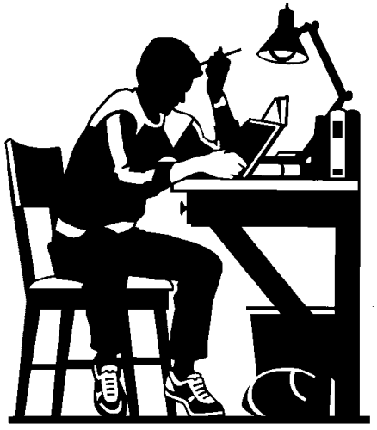
Tardiness and Absences are handled according to the district policy which can be found in the student handbook. See #5 above.
